**C++ Assignment**

**Home Task 1:**

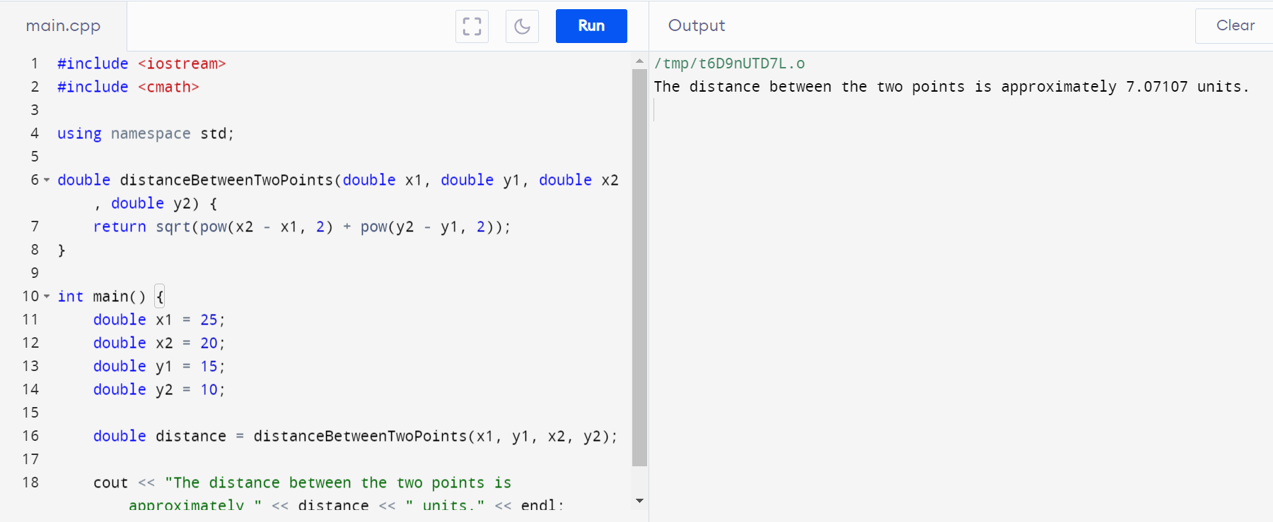

**Home Task 2:**

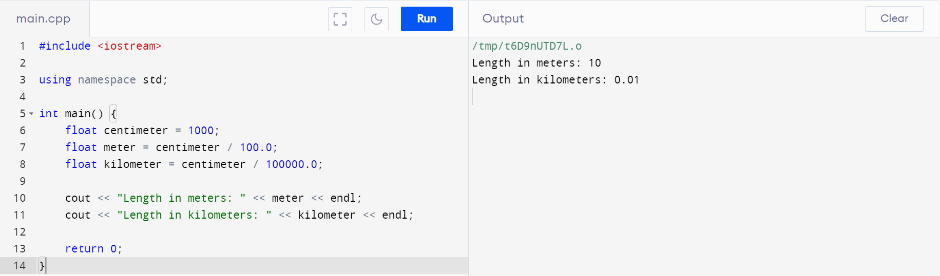

**Home Task 3:**

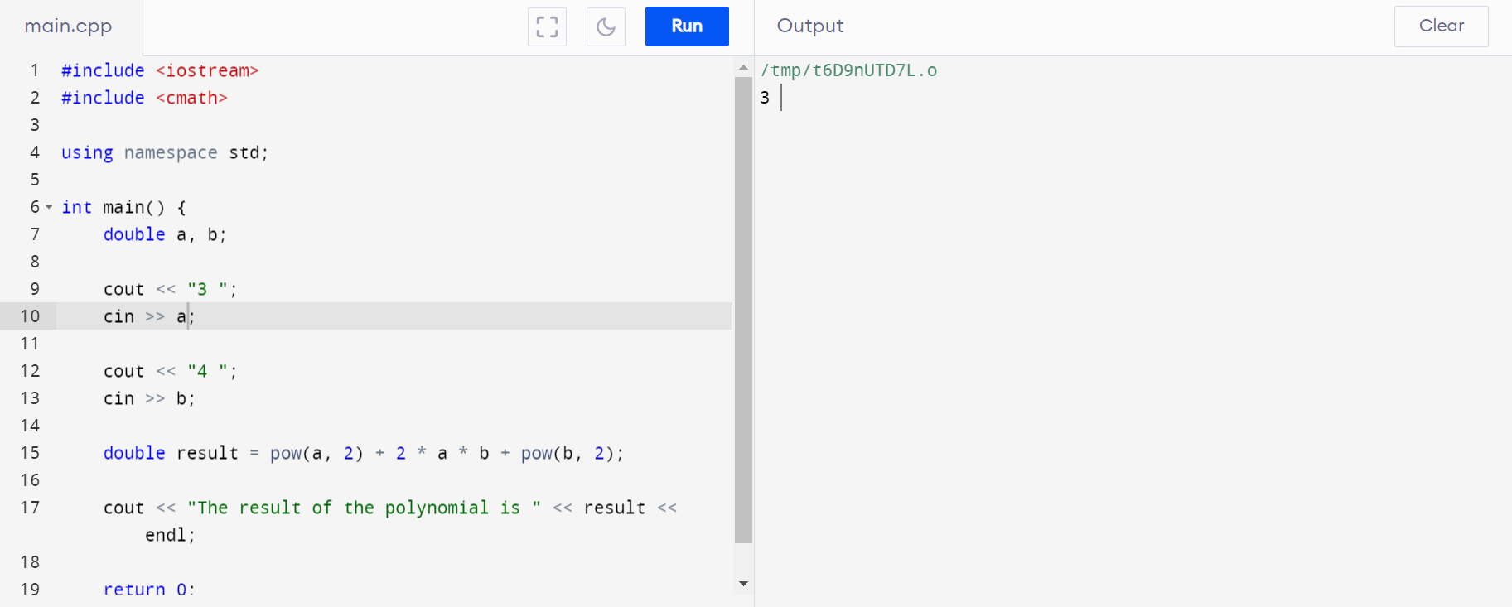

**Home Task 4:**

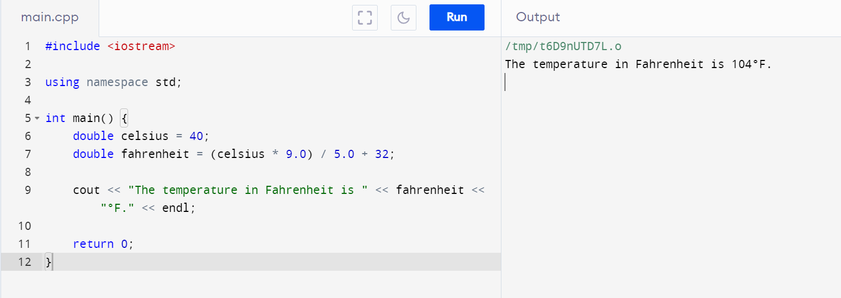

**Lab Task 1 (From Lab Manual 2):**

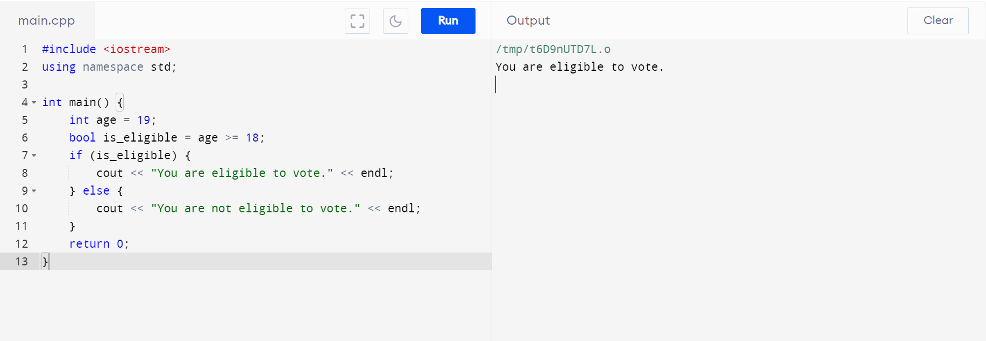

**Lab task 2:**

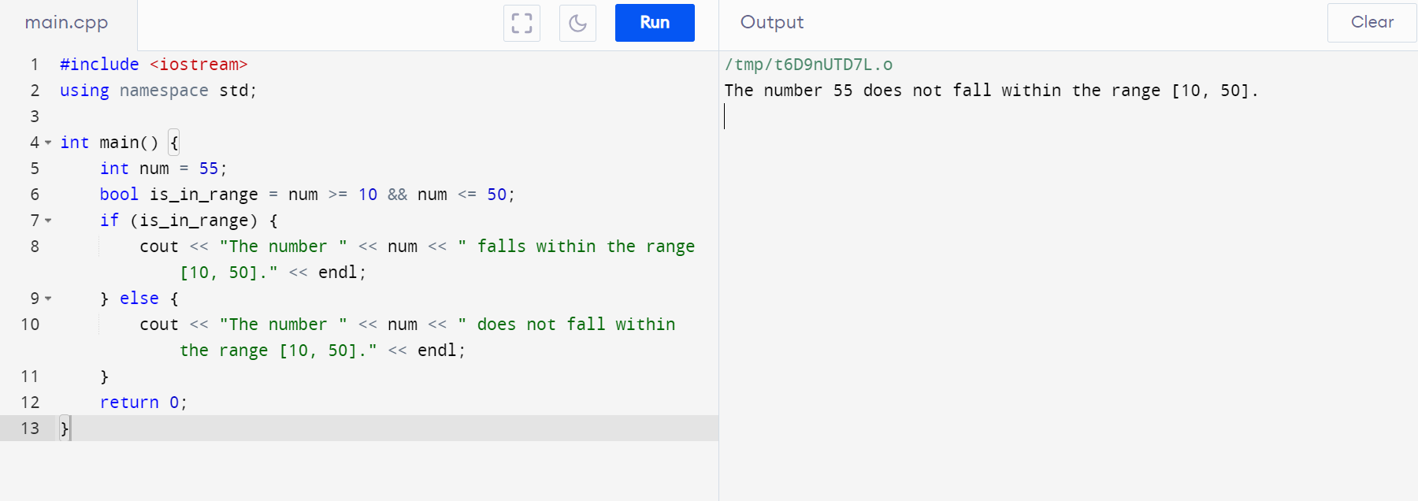

**Lab Task 3:**

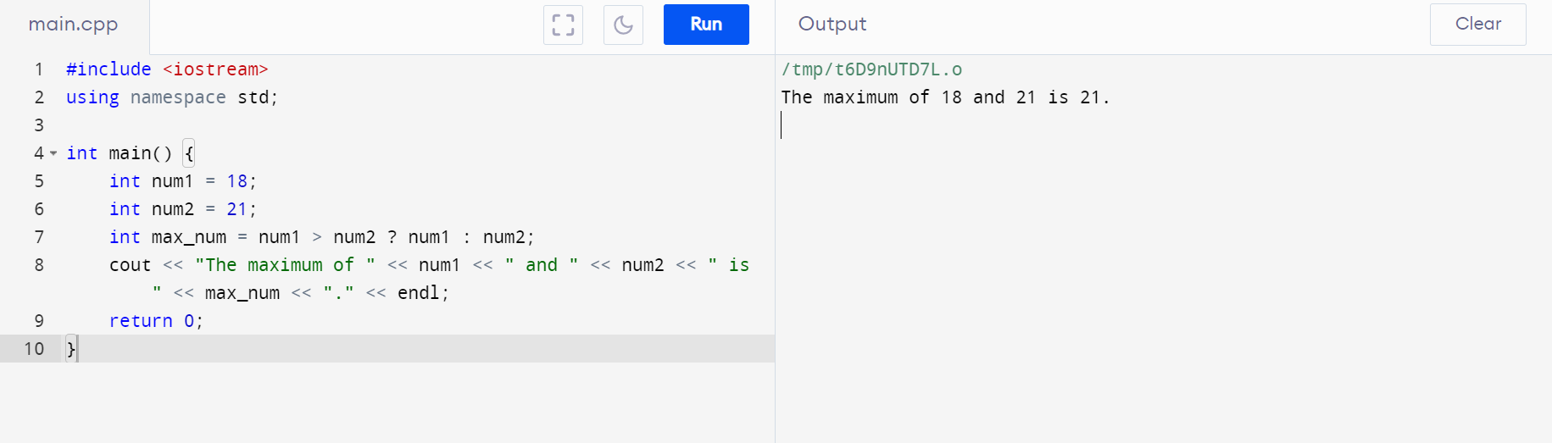

**Lab Task 4:**

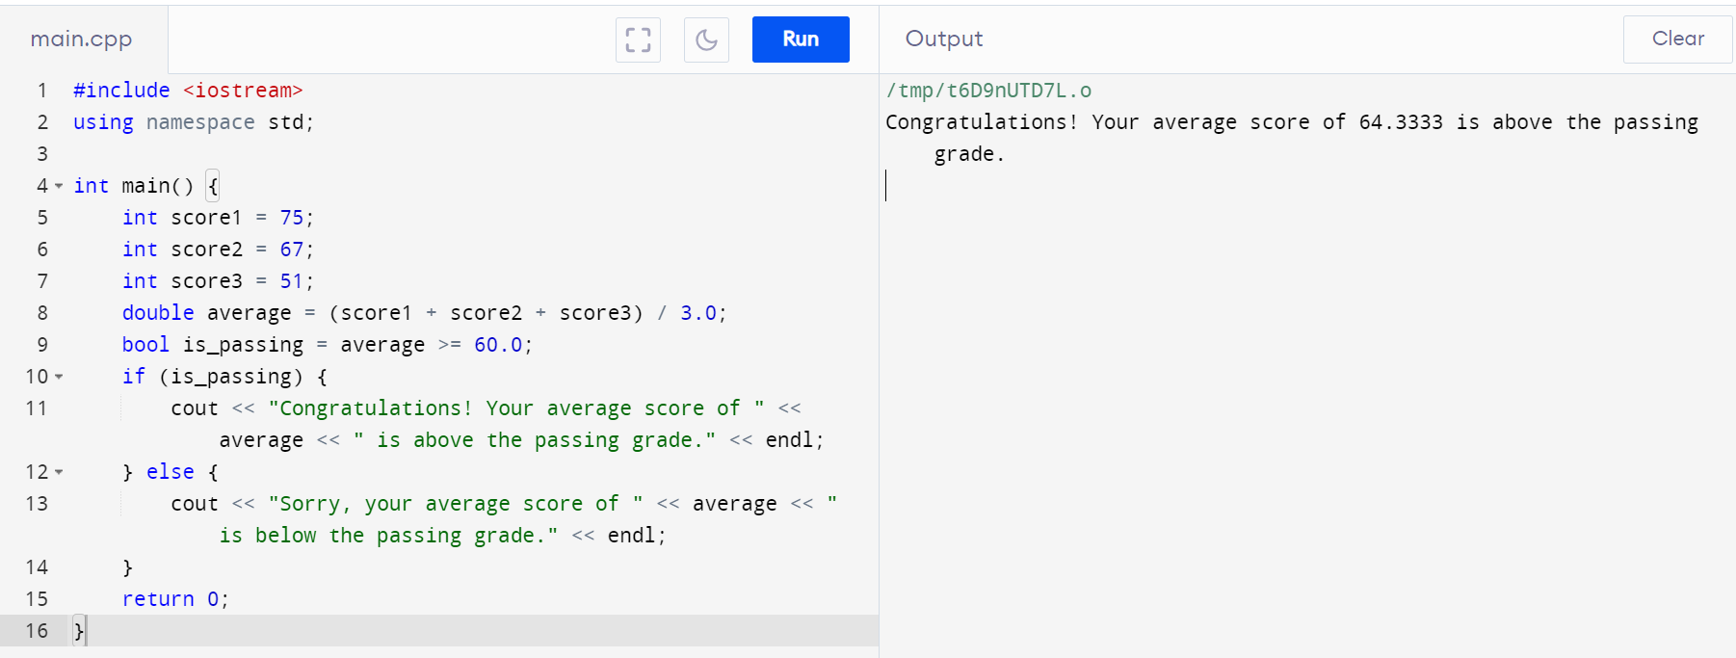

**Home Task 1 (from Lab Manual 2):**

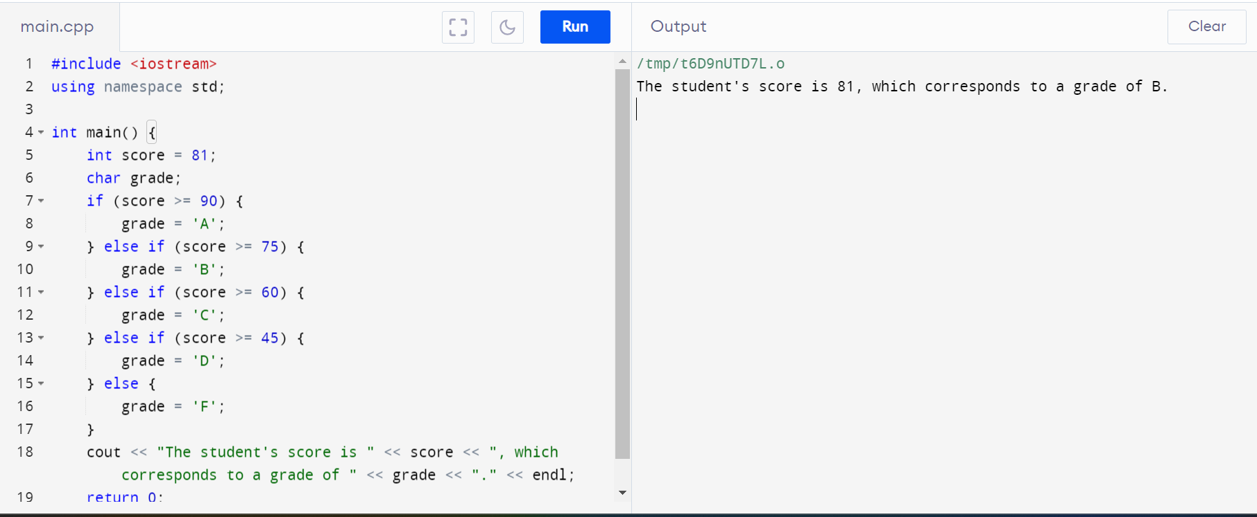

**Home Task 2:**

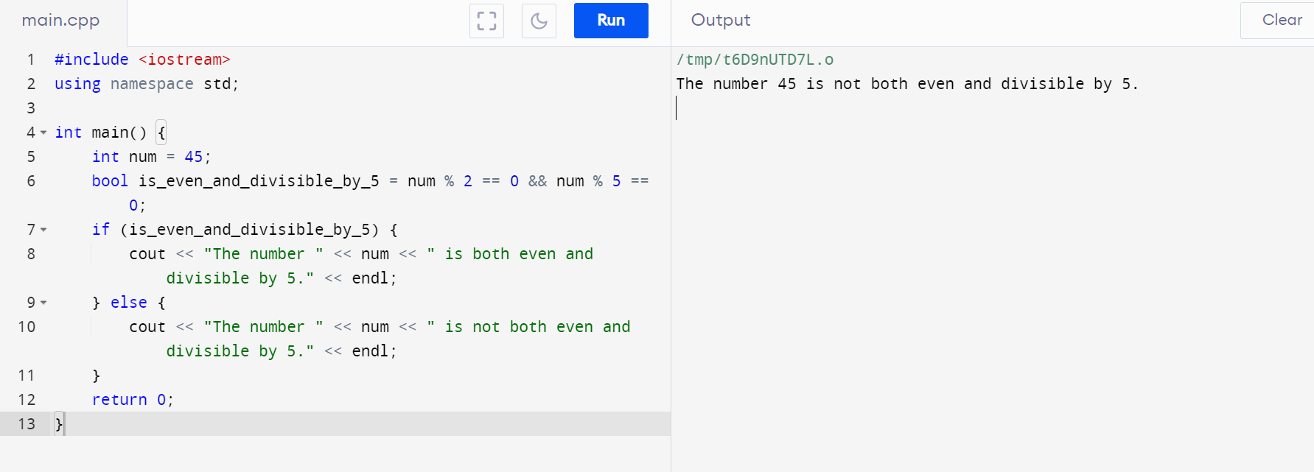

**Home Task 3:**

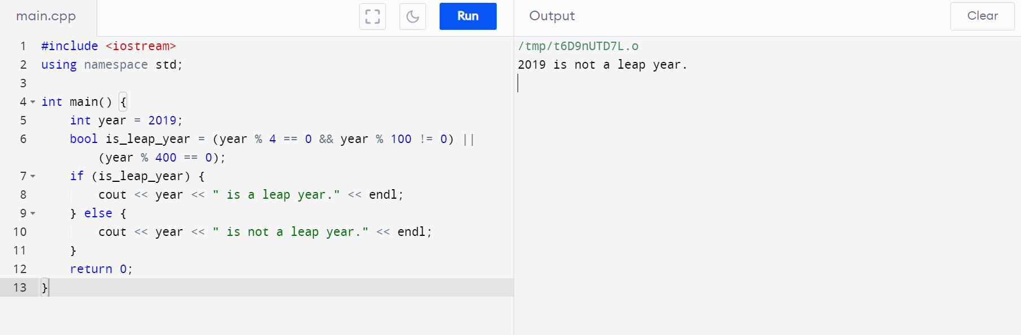

**Home Task 4:**

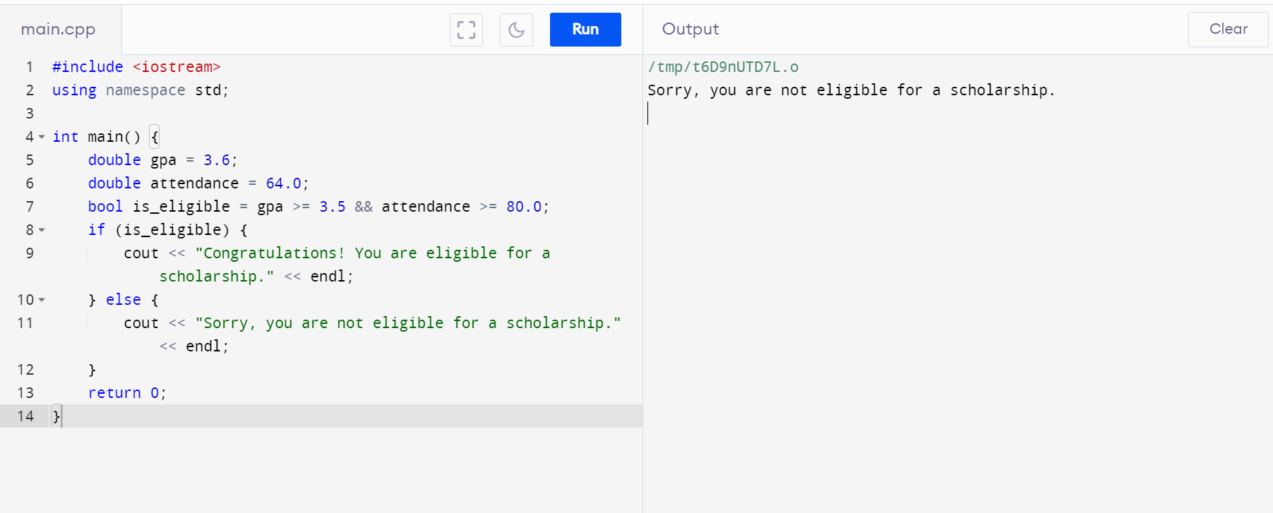

**Home Task 5:**

